(This continues the 2014 Wyoming History Tour, Days 3-5)
DAY 3: Johnson County
After a bus drive-by of the Three Crowns golf course remediation site where the Standard Oil refinery once stood, the tour continued to Johnson County.
The Salt Creek highway north of Casper was the first stretch of roadway in Wyoming that was paved--done so to accommodate oil trucks coming into Casper from Salt Creek and other oilfields to the north. Also in north Casper was the site of Wardwell Field, Casper's first airport, named for Maj. D. P. Wardwell, organizer of Wyoming Airways who died in a crash in 1929. The field closed in 1952 and the town of Bar Nunn was built on the site.
Also north of Casper was the site of "Discovery Well," the first producing well in Natrona County, brought in by Cy Iba about 1887. In its first years, Casper was a wool town where shipments of wool sacks from the train depot augmented the economy. After additional oil discoveries in the early 1890s and construction of the first oil refinery in 1895, Casper became the "oil capital of the Rockies." Natrona County had the greatest assessed valuation of any in the state in 1929 when license plate county numbers were designated.
Much of the oil came from Salt Creek field where, in the first decades of the 20th century, the field led the nation in production. The town of Midwest, established as a company town by the company operating the field, was the site of the first night high school football game (November 1925, Casper beat Midwest 20-0). The company declared Midwest to be "dry" (no alcohol allowed) and restricted gambling and other illegal activities. Consequently, the sister city of Edgerton was founded on public land next door where oil workers could find vices they may have desired.
South of Midwest is the site of the Teapot Dome naval petroleum reserve. The field gave its name to the biggest Presidential scandal in the first decades of the century when Interior Secretary Albert Fall induced the Secretary of the Navy to transfer control to Interior and then Fall illicitly leased drilling rights to oilmen Harry Sinclair and Edward Doheny. He was later convicted of accepting bribes and sent to prison.
North of the Natrona-Johnson county line is the town of Kaycee, so named for the brand of the KC ranch. The town's best-known resident was Chris LeDoux (b. 1948, d. 2005), world champion bareback rider in 1976 and popular singer and songwriter. He is memorialized with a monumental bronze statue in a park on Kaycee's main street, by D. Michael Thomas, dedicated in 2010.
A couple of town blocks south of the statue and on the opposite site of the road is the now-empty pasture where the KC Ranch building once stood in which Nate Champion held off the army of Invaders for several hours in April 1892, until the building was set afire, he ran from it, and was cut down by rifle fire.
After noting the road to the Hole-in-the-Wall country--where outlaws including the Wild Bunch--once hid from the law and the road to the Dull Knife fight site, we returned to the Interstate and continued north to the TA Ranch, the site where the Invaders sought to hold off Buffalo residents while waiting to be rescued by the army after their ill-fated excursion into Johnson County. It was here where the actual invasion, the infamous feature of the Johnson County War, occurred and where the "war" phase came to an end.
The ranch, originally homesteaded by Dr. Harris from Laramie in the 1880s, was purchased in 1992 by Earl and Barbara Madsen, who hosted the group for dinner and showed them around the historic ranch.
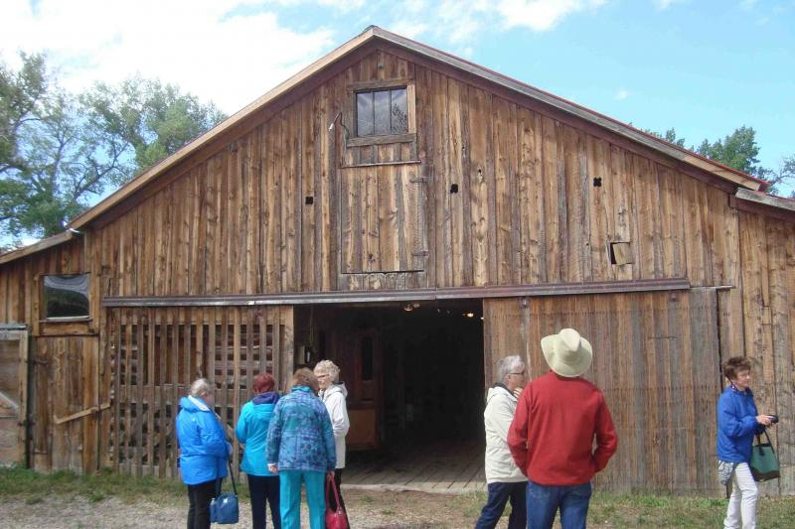
Pictured is the barn where many of the gunmen barricaded themselves, cutting rifle notches in the walls and avoiding bullets fired from the Buffalo residents arrayed around the ranch in the three-day siege.
Despite cool morning temperatures, the group watched Dave, a "horse-whisperer" trainer, work with a horse in a temporary corral.

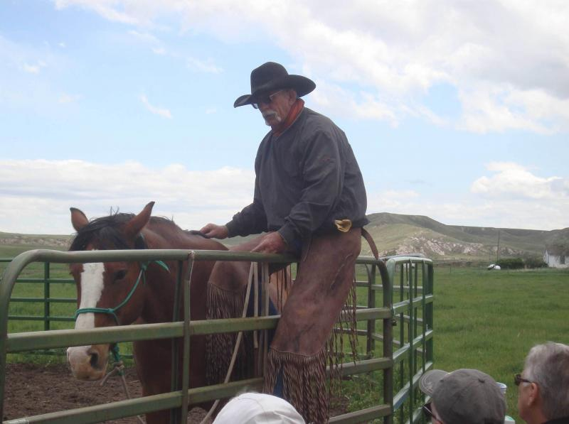
He talked about how one can read horses' body language and horses do the same with humans. Consequently, very little movement can direct horses to do certain things. It was a fascinating hour-long look at humane, intelligent horse training.
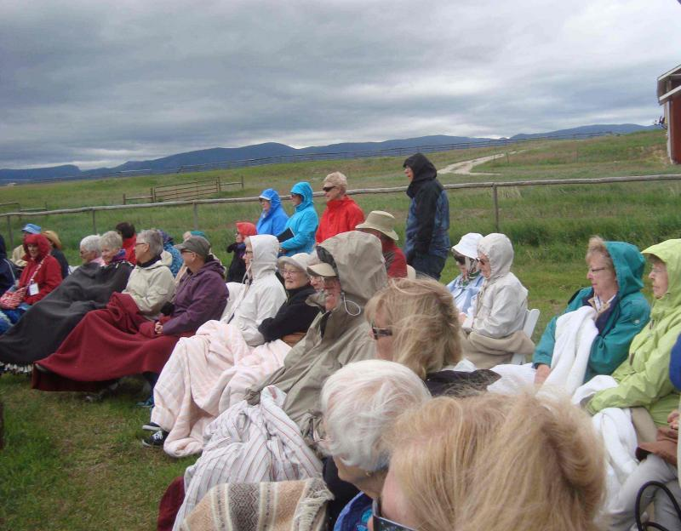
Shortly after this photo was taken, the clouds cleared away, the sun
came out and everyone enjoyed the cool late spring day on the ranch.
Later, while Earl Madsen hosted visitors on a ride around the ranch on a wagon drawn by a matched team of Percherons, Barbara Madsen described the events of the Johnson County War that occurred there on the ranch.
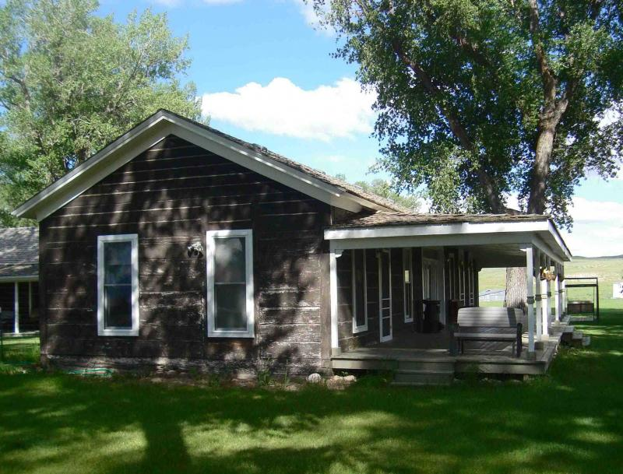
TA ranch house where the leaders of the Invaders waited out
a three-day siege by Johnson County residents prior to being
rescued/arrested by the army.

After dinner indoors in the "cook-house," the group sang some classic Western songs, led by Nancy Chase who also sang several solos. Later, the bus returned to the hotel.

DAY 4: Casper area sites and museums
First item on today's agenda was a walking tour of the old Sandbar district of Casper (where we were met and welcomed by Casper's city manager).﻿ ﻿ The district was a wild place during the oil boom after World War I and again when the Casper Army Air Base opened during World War II. None of the original buildings exist today. The current Casper City Hall is built on part of what was the Sandbar.
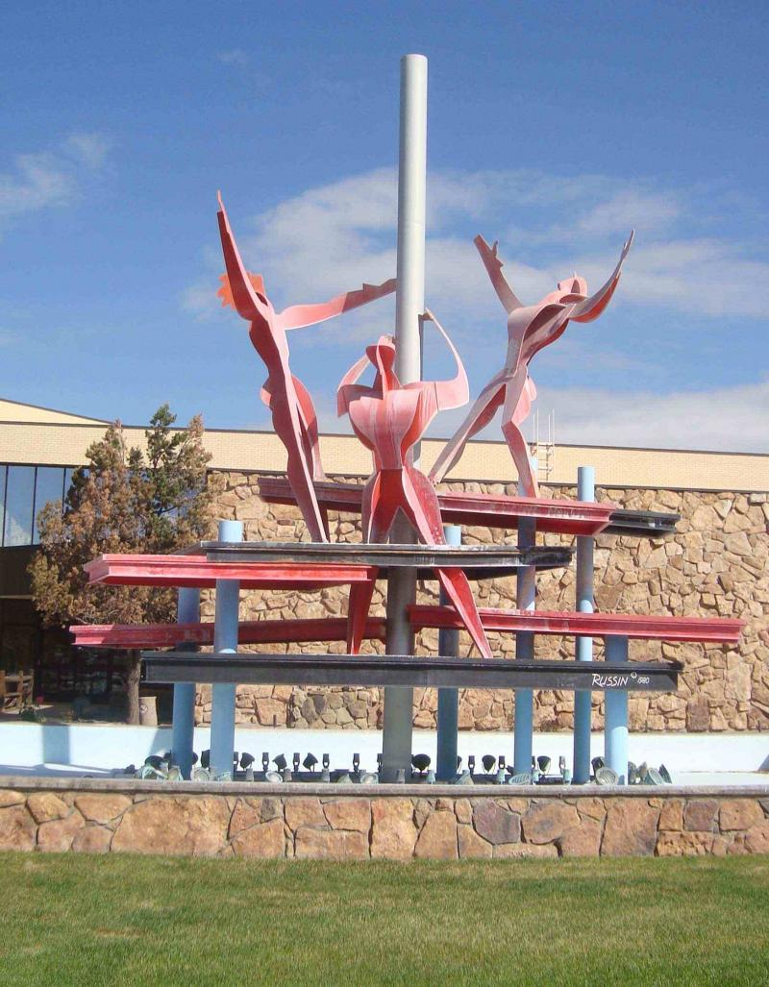
Robert Russin's sculpture/fountain stands in front of Casper
City Hall, located in what had once been the Sandbar district.

In the previous city hall, Wyoming's second-ever constitutional convention was held in 1933 to repeal Prohibition. One particularly notorious Sandbar house of prostitution stood in direct view of the window in the sheriff's office in the original county courthouse.
The present courthouse, completed with PWA/WPA funding in 1940, features pediments and friezes of covered wagons and oil wells, typical of the style of New Deal designs.
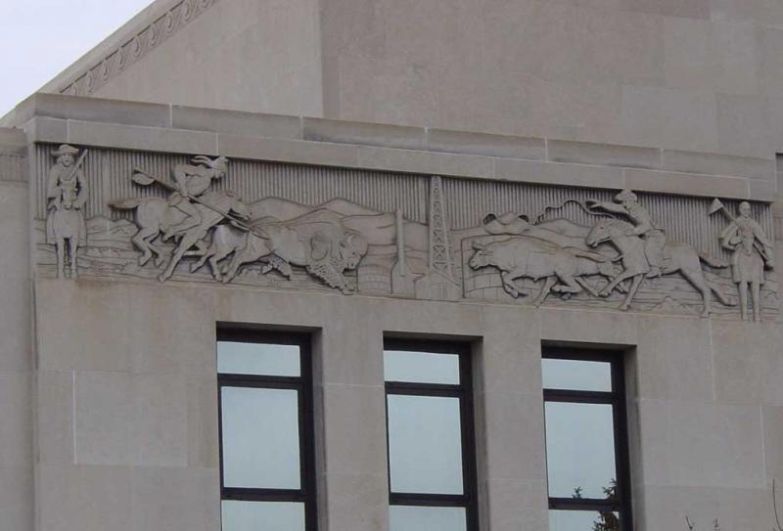
Frieze on east front of the Natrona County Courthouse, south of the front entrance
Down Center Street south from the courthouse is the corner of 1st and Center, once occupied on three corners by Casper hotels all built to accommodate high-end investors/visitors to the "oil city" in the 1920s. The five-story Townsend Hotel (1923) was the site of Casper's first radio station and first commercial station in Wyoming, on the air for the first time Jan. 2, 1930. The Gladstone Hotel on the northwest corner, at eight stories, was the tallest building in Wyoming from 1924-1965. The Henning Hotel was built by the Midwest Oil Company on the southeast corner of 1st and Center. It was bought later by plumbing contractor Welker F. Henning, Casper's first millionaire, and renamed for him. The Midwest Oil Exchange, the site of market trading of "penny stocks" in oil companies during the oil boom after World War I, was located nearby.
A block south, on the corner of 2nd and Center, is the Rialto Theatre (built as the New Lyric Theater in 1921), site of Wyoming's first "talking picture" movie house. East on the same side of 2nd Street is the Tribune Building built by publisher Earl Hanway in 1920 and once the home of the Tribune-Herald, Casper's largest newspaper until its merger with the Casper Star in the early 1960s. (The Casper Star-Tribune offices are a block west of Poplar on West 1st Street).
After a drive past the Natrona County Library (and another Robert Russin statue in front of the building), the bus continued east on 2nd street. The historic Bishop house, home to Marvin Bishop, a prominent Casper resident and a founder of the Wyoming Woolgrowers' Association, is located on the north side of 2nd Street. Time constraints made it impossible to drive by other historic properties such as the Henning House (1108 S. Wolcott), the B.B. Brooks house (1208 S. Wolcott), the Cunningham Mansion (1110 S. Center), the Patrick Sullivan house (109 E. 10th St. and the oldest in the district, built on land owned by J. M. Carey and given to Sullivan with the stipulation that he build a "grand house" to show off the potential for the neighborhood) and other homes in the South Wolcott Street Historic District.
Nearby is the First Presbyterian Church, the home church of Casper native the Rev. James Reeb, who was killed by Ku Klux Klan radicals in Selma, Alabama, in 1965. Reeb, a minister and civil rights activist, had just arrived in the South. His murder helped ensure passage of the Voting Rights Act.
Next destination was the Trails Center on the north side of Casper. Visitors enjoyed exhibits showing the story of Oregon-California-Mormon trail travelers from 1843 to the 1860s.
From there, the tour continued to another Casper site, Fort Caspar, west of downtown when travelers had lunch in the picnic area west of the museum
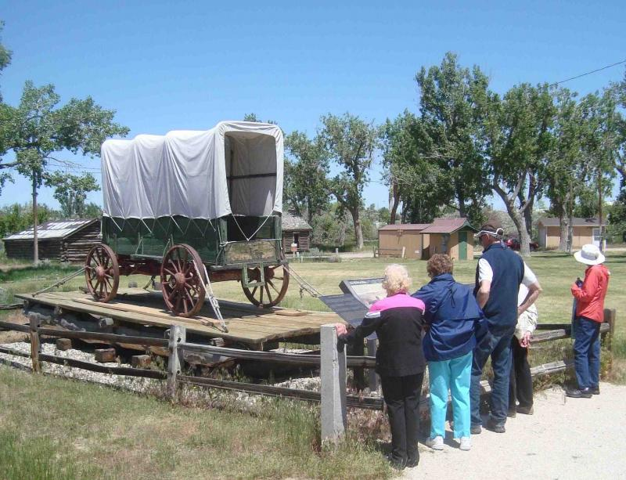Later, they followed self-Travelers read the sign telling of the original ferry that preceded bridge construction at the site near present Fort Caspar Historic Site on a guided tour of the 1935 reconstructed fort, built originally on the site of Platte Bridge Station in 1866.
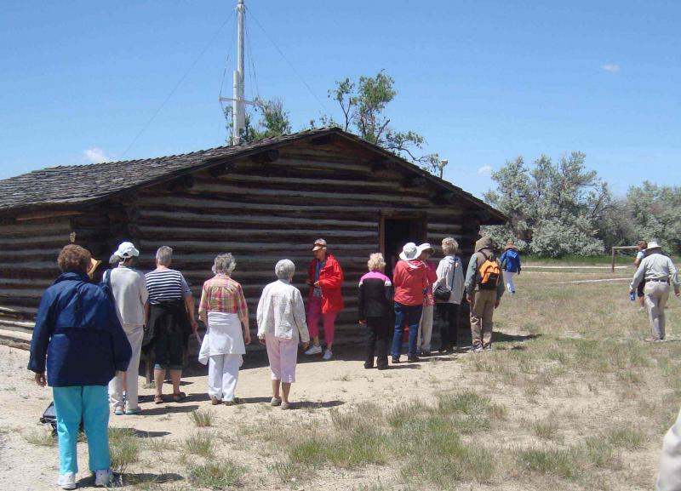
The building pictured here once served as the museum, but was replaced by the new modern building in the 1970s

Interior exhibits in the visitor center and museum showed later stages of Casper's history, including the oil boom periods in the 20th century. South of the main entrance to the site, owned by the City of Casper, were the two statues seen in Lander being loaded at the bronze foundry two days earlier.
From Fort Caspar, the tour continued to the Wyoming Veterans' Memorial Museum, established in what had been the Enlisted Man's Club on the former site of Casper Army Air Base, west of Casper. 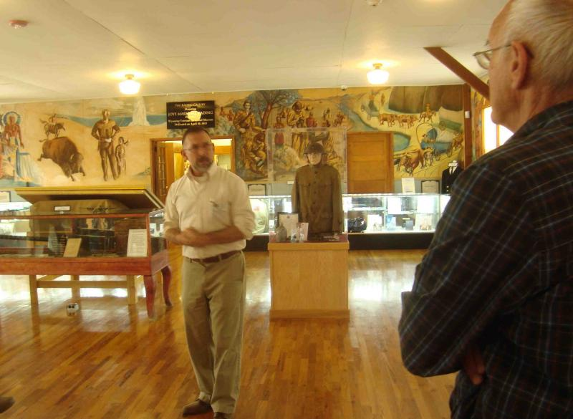The visitors looked at murals painted by several airmen and heard museum director John Goss provide a description of the various military exhibits and murals.
Casper Army Air Base was an important training base for B-17 and B-24 bomber crews. Among the trainees were all-African-American units (the armed forces were not racially integrated until President Truman issued an executive order to do so after World War II). Chuck Yeager, famed test pilot, trained for World War II service at Casper Army Air Base.
After a dinner of salmon or steak at the historic Wonder Bar in downtown Casper, the group returned to the hotel to hear a description of the Three Crowns/Standard Refinery site remediation. 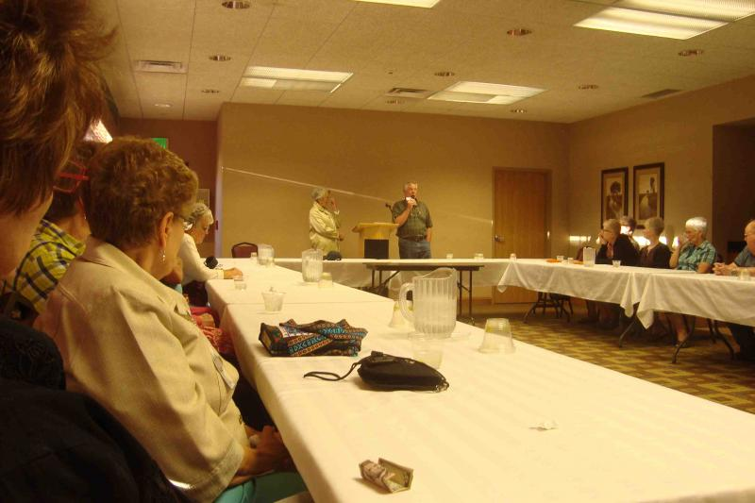Presenters were current Natrona County Commission chair Bill McDowell and former first lady of Wyoming Jane Sullivan. Both were active in the remediation effort in the 1990s.

DAY 5: Douglas area sites and museums
As the bus drove toward Douglas, we saw Edness Kimball Wilkens State Park to the north of the Interstate, named for a long-time legislator. At the east side of Casper is a statue of four oilmen, modeled after some of Casper's most distinguished citizens--Fred Goodstein, Mick McMurry, Dave True and John Wold--done in 2005 by Seth Vandable.
Brooks Road is named for one of the largest landowners in Natrona County at the turn of the 20th century--B. B. Brooks, sheep rancher and governor of Wyoming.
A few miles down the road, the highway passes to the north of the Big Muddy oilfield where, in 1916, a huge gusher came on a university-owned section. The resulting royalties allowed for UW to build Half Acre Gym and the Aven Nelson Building (UW's library at the time) when many other universities in the West were in financial distress.
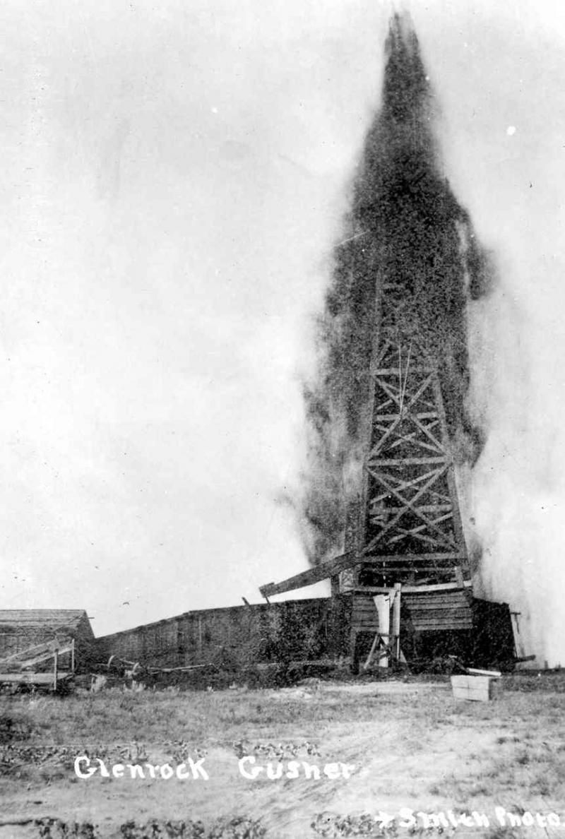
Big Muddy Oilfield gusher, 1916. Photograph by George "Coyote" Smith,
Glenrock. Collections of the Wyoming State Parks and Cultural Resources
Department, Cheyenne.

Farther down the road, the bus turned off the Interstate and onto a narrow road leading to Ayres Natural Bridge, a 150-acre county park located southwest of Douglas.
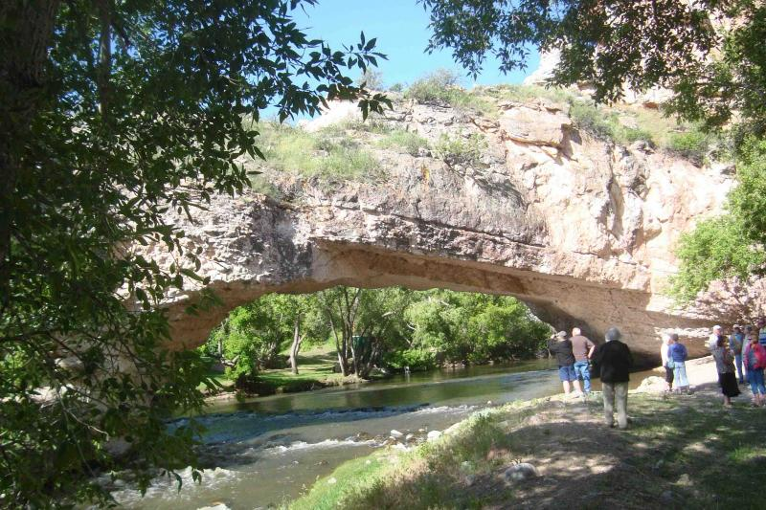The main feature, the natural arch over LaPrele Creek, is 30 feet high and 50 feet across. Visited by Indians for eons and by explorers and Oregon Trail travelers, the site remains a favorite picnic and camping area for Converse County residents.
Back on the Interstate highway, the bus passed the site of Fort Fetterman, now a state historic site, and briefly a military post in the 1870s. After the post was closed by the army, a group of local cowboys and cattlemen formed the nation's first cooperative health care organization on the site--the Fetterman Hospital Association.
The bus continued to Douglas and a stop at the Wyoming Pioneer Museum on the grounds of the Wyoming State Fair. The group toured the museum and ate lunch on the picnic tables east of the museum.
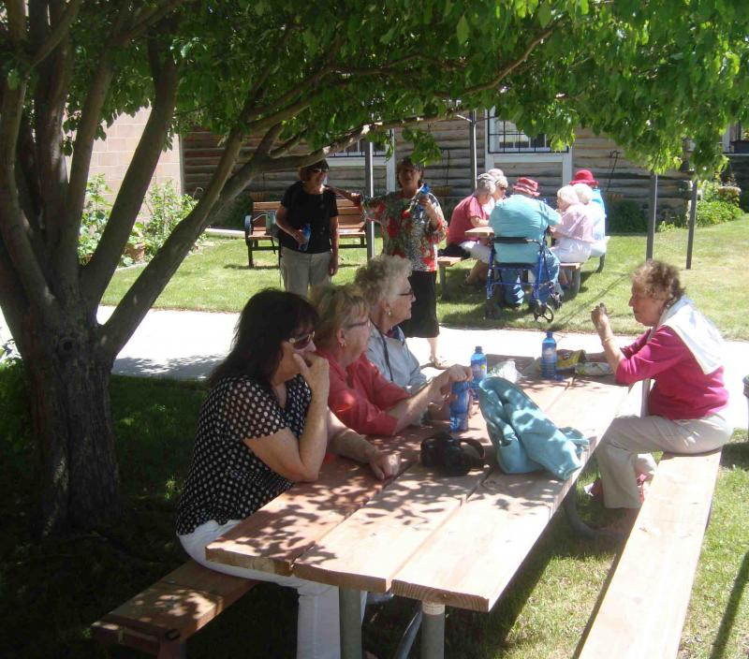
Travelers ate an early lunch on the grounds of the Wyoming Pioneer Museum.
Director Arlene Ekland-Earnst offered to lead the travelers to the former World War II prisoner-of-war camp west of Douglas.
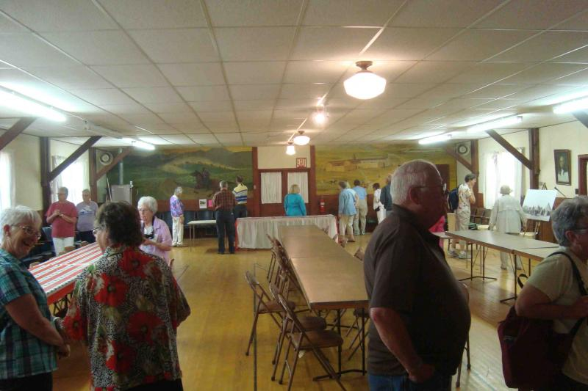
Murals, copied from well-known Western paintings, were done by Italian POWs in 1943. The building will open officially next year as a historic museum site.
The bus then took the travelers to the Wyoming Law Enforcement Academy, on the northwest edge of Douglas.
After the history guide brought attention to those honored on the honor roll of law officers killed in the line of duty, the WLEA staff demonstrated various activities taught at the academy.

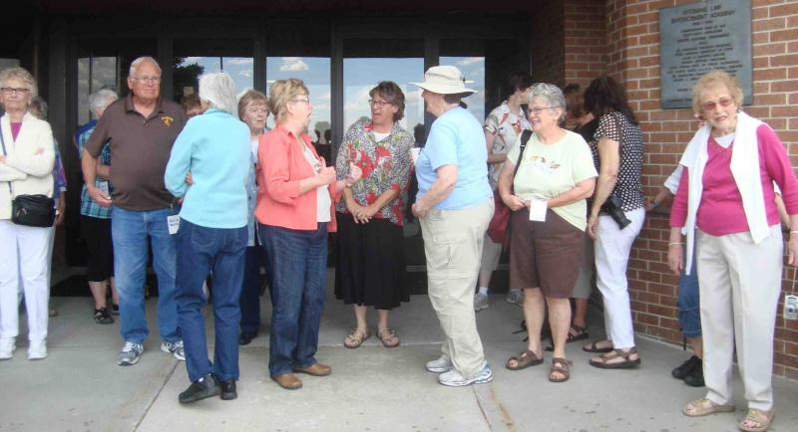
The indoor firing range, used only on days when high winds do not allow outside training. The WLEA assistant director also talked about the use of tasers in law enforcement.
The history guide made reference to Douglas' location as the site where the jackalope first "appeared"--in the taxidermy shop of Ralph and Douglas Herrick about 1935. Later that evening, the travelers enjoyed wine and a catered dinner at the hotel.
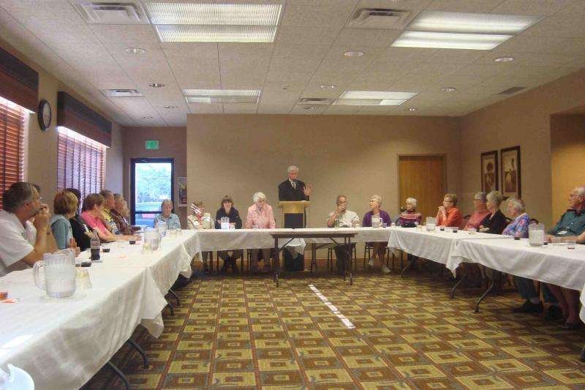
A surprise visitor, Edward Ivinson (who bore a striking resemblance to Kim Viner, told about parties held over the years at the Ivinson Mansion in Laramie.

