Wyoming History ‘on-the-road’ Tour (2016, 1st half)
Every two years in the past decade or so, the Laramie Plains Museum has sponsored a "History of Wyoming on-the-road" tour of historic sites and interesting locations around Wyoming. The 2012 trip circled much of the state; in 2014, the trip covered locations in central Wyoming. In 2016, the northeastern quarter of Wyoming was explored. What follows are day-to-day accounts of that trip with a few accompanying photographs. No tours were held in 2018 or 2020.

DAY 1 (June 13, 2016)
Thirty-eight people arrived at the parking lot behind Spring Creek school to begin our biennial trip. This time, we concentrated on sites and history in northeastern Wyoming, two years ago, looking at locations throughout central Wyoming (from Douglas to Lander, Buffalo to Independence Rock). Oddly, both the guide and the bus driver were named "Phil."
As we traveled north, we drove past Glendo Reservoir (uncommonly very full from the heavy rains this spring) and, as we passed over Cottonwood Creek, noted the place where Dr. Aven Nelson and a colleague dug up cottonwood saplings for transplanting in Laramie in the early 1900s. As we crossed the North Platte River, we noted to the west, the general location of Bridger's Ferry, built by mountainman Jim Bridger in 1864 and, from 1866 to late summer 1867, the starting point for most traffic on the Bozeman Trail.
After getting on U. S. Highway 20, eastbound, we viewed, from the road, the smallest incorporated town in the state (Lost Springs). In 1976, the BBC featured Lost Springs as the "smallest incorporated town in America, officially celebrating the bicentennial." The town population has doubled since then--now four, according to today's road sign.
We drove past the site of Jireh where a colonizing group from Ohio formed a dry farming community in the early 1900s. They built a three-story building housing Jireh College, a two-year college training students in a wide variety of disciplines. The college operated until drought and economic hardship forced its closure in 1920.
As we passed by Keeline on the south of the highway, we noted the presence in the cemetery of the memorial honoring the six former residents who died in World War II--representing all four branches of the armed forces.
Manville, down a road a few miles, once had been a competitor with Douglas and Lusk for county seat, first of Converse County and then, Niobrara County. The population now numbers about 50 with only the Three Sisters Cafe as a business.
As we were entering Lusk, just to the west of town was the grave of George Lathrop, pioneer stagecoach driver for the Cheyenne-Black Hills stageline. Lathrop, born in Pennsylvania in 1830, had a colorful career as "Indian fighter" and stage driver. He died in 1915 and, 15 years later, a memorial plaque was placed on his grave. (The grave is located on the west end of the rest area).
We stopped at Lusk for lunch, served at the fairgrounds by caterer Terri Goddard. Lusk area historian Anne Willson Whitehead joined us and talked about the earliest days in Niobrara County when her grandfather and great-uncle began the Running Water ranch and built the first homestead cabin in what would become the county. She and fellow Lusk native, our history guide Phil Roberts, talked about some incidents in the early history of Lusk, talked about the Legend of the Rawhide pageant, the Niobrara County Fair and Rodeo and noted a number of famous former residents. Anne then joined us for a brief stop at the "Old Cabin" in Washington Park, the oldest standing structure in the county, given to the DAR in 1927, moved from the site of the Running Water Ranch west of Lusk and reassembled in the park two years later. Prior to meeting Anne at the cabin site, the group walked around the corner from the fairgrounds and viewed the nation's smallest operating oil refinery. The historic site was founded in the early 1930s as C&H Refinery, the initials standing for the first letters of the founders' last names (Chamberlin and Hoblit).
A windshield tour of Lusk followed with a brief stop at the Redwood Water Tank, east of Lusk, built by the Fremont, Elkhorn and Missouri Valley Railroad for the company's steam engines in 1886. It is one of only six redwood tanks still in existence. As we left Lusk, we followed the detour around the highway overpass, washed out by the flood waters of June 4, 2015, almost exactly a year and a week before our trip. The flood caused devastation of dozens of homes and businesses in a rare event Lusk had never experienced in its prior history. (The event is documented in a forthcoming book by Phyllis Hahn, to be published later this year).
North of Lusk, our history guide pointed to the ranch where author/poet Mae Urbanek and her husband once lived. Among her works was Wyoming Place Names, a book still in print a half century after it was first published.
The road generally followed the route of the Cheyenne Black Hills stage route until we came to the Hat Creek Breaks. There, the stage road went off the breaks into a valley and to its major stop in this part of the trail, the Hat Creek Stage Station. From our viewing point at the top of the Breaks, we glimpsed the valley below, the location of our guide's first home, a ranch held in the Roberts family until the middle 1960s.
We passed the rapidly deteriorating ruins of a store and gasoline station, operated by Dudley Fields for many years also as the Hat Creek post office and the only major structure in Hat Creek. The town's entire population including its mayor, police chief and leading citizen, diminished to zero in 1967 when Fields died of a heart attack.
We crossed the Cheyenne River near the location of "Robbers' Roost," a haunt for stagecoach robbers trying their luck on coaches going back and forth between Cheyenne and Deadwood for a dozen years in the 1870s and 1880s. Nearby is the long-abandoned Cheyenne River School, one of dozens of country schools operating in Niobrara County prior to 1952. (Wyoming had 399 school districts in 1935, including districts consisting of tiny rural schoolhouses. The current number is 49).
We stopped briefly at the state rest area at Mule Creek Junction. In the distance to the west were gigantic black thunderstorm clouds. By the time we arrived at our hotel in Newcastle, heavy rain was falling and we had to scurry out to pick up suitcases and check into our rooms.
The storm passed through before supper time. We boarded the bus once again and traveled to Canyon Springs Stage Stop Steakhouse, opened three years ago near the site of the Canyon Springs Stagecoach Station, a few miles north of Newcastle. Owners Frank and Judy talked about the history of the steakhouse and the area. After a fine steak or chicken dinner (depending on one's preference), we watched deer in the nearby meadow next to an abandoned homestead cabin. (Everyone loved the food--well worth driving out of one's way a bit). Nearby was the site of the stage station as well as the spot where stage robbers attacked the coach in Sept. 26, 1878. (See article written in 1978 by our guide, Phil Roberts, and used on the menus).
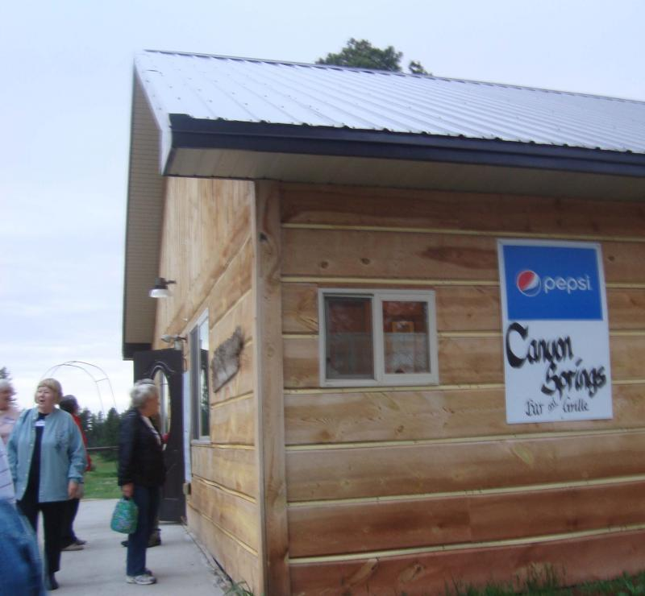
Some of the group leaving the Canyon Springs Stage Stop Steakhouse where
dinner was served on Day 1. The steakhouse is located near the site of Canyon
Springs stage station where stage robbers held up a stagecoach in 1878.

﻿
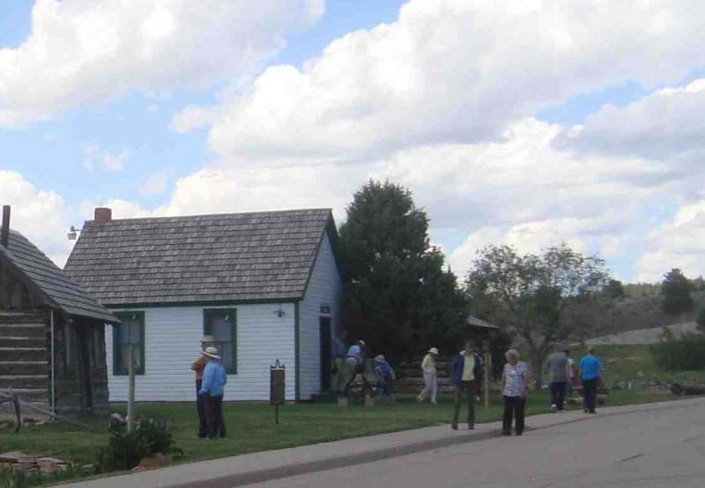
Three historic structures are located across the road from Newcastle's Anna Miller Museum.
Shown are our travelers visiting the homesteaders' cabin, the old country schoolhouse
and the Jenney Stockade cabin. All were moved to the site in the past 30 years.

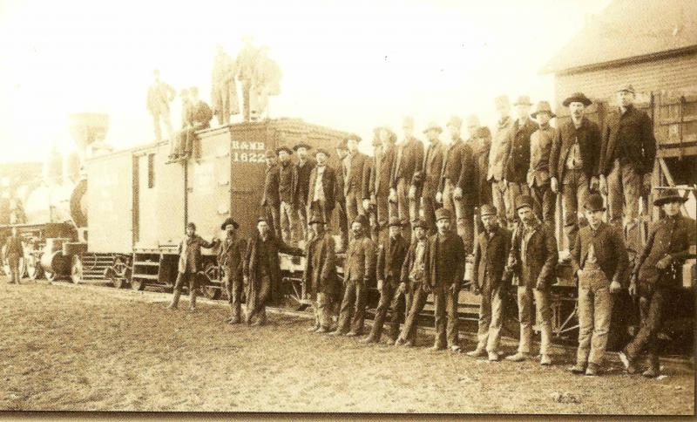
Newcastle, as the first train arrived in the new town, 1890.

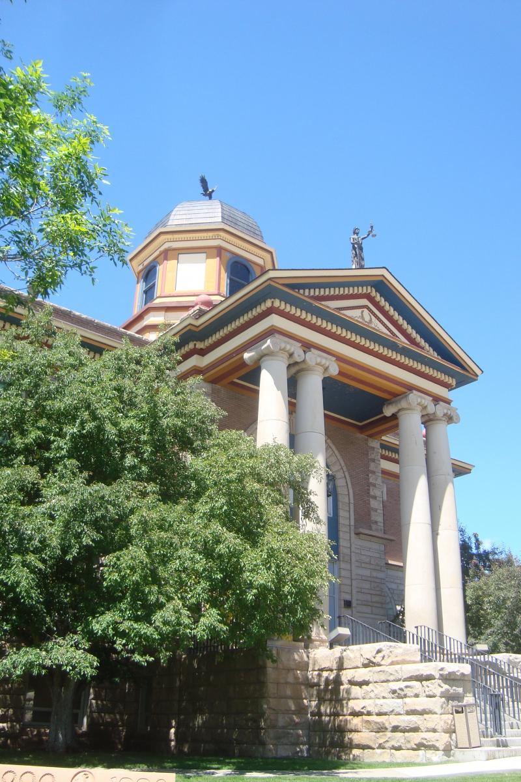
Weston County Courthouse, Newcastle, June 2016. Phil Roberts photo.

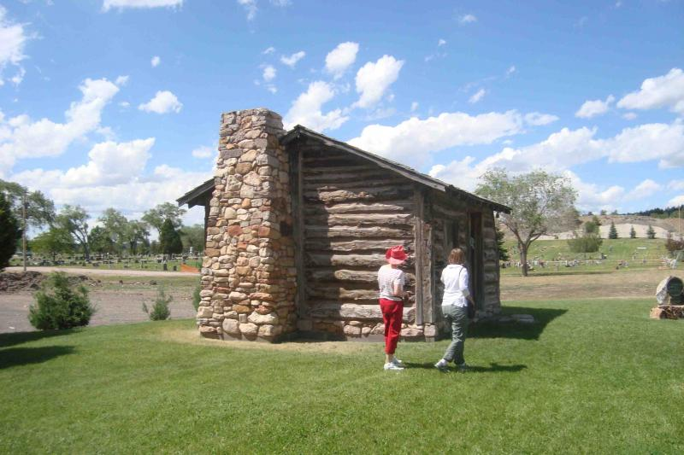
Jenney Stockade cabin, Anna Miller Museum complex, Newcastle, June 2016
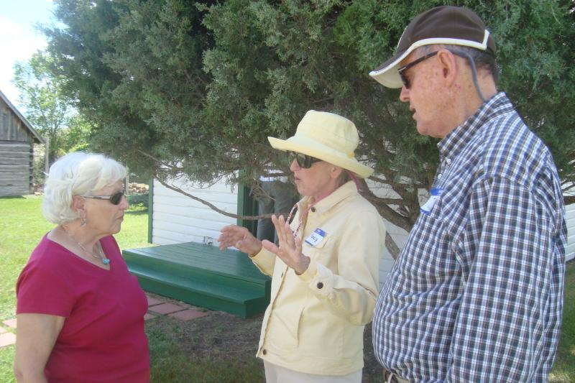
Three travelers visiting in the shade at the Newcastle museum. Phil Roberts photo
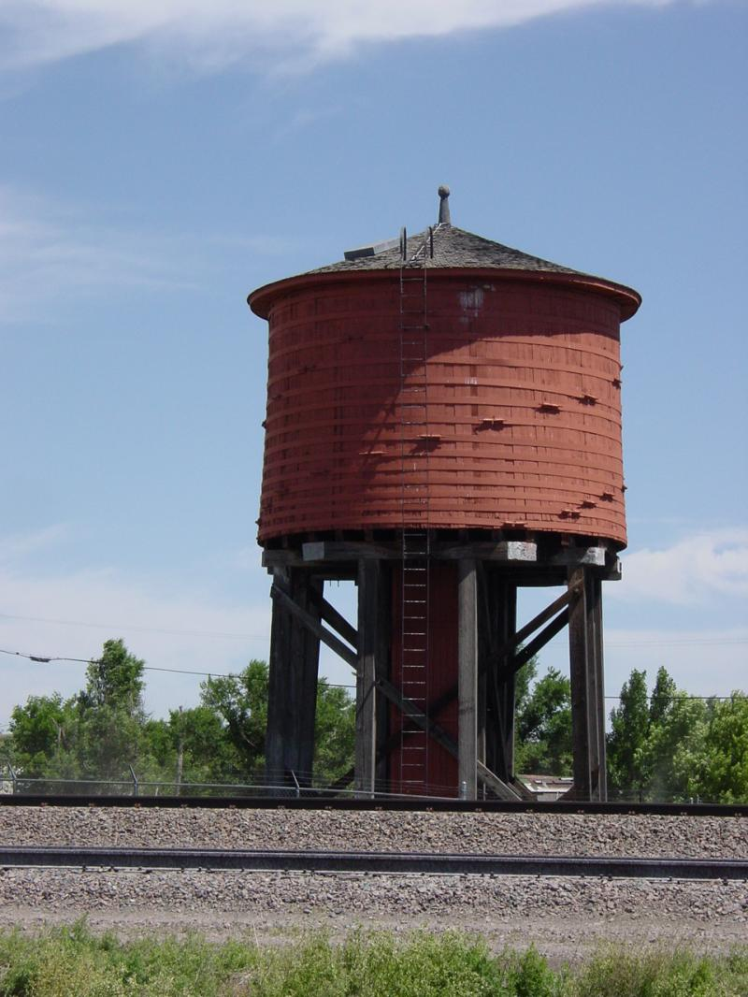
﻿﻿Redwood Water Tank, east of Lusk, built by the railroad in 1886 for steam-powered
locomotives, one of only six tanks still in existence. (Phil Roberts photo)

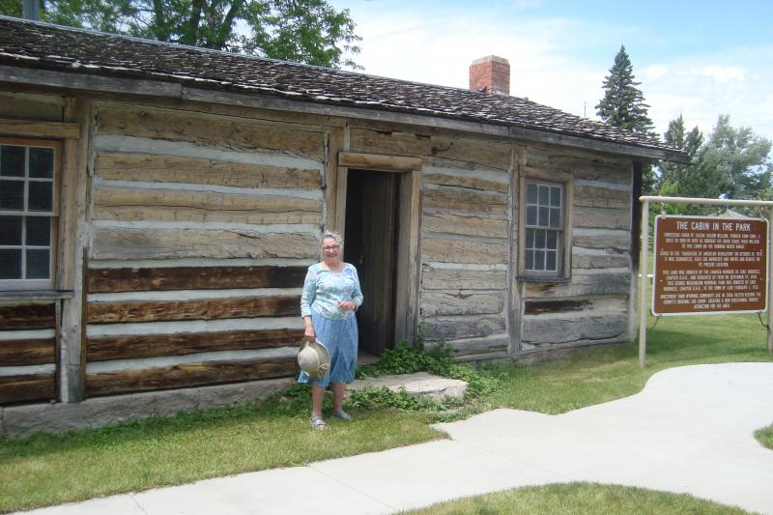
Author/historian Anne Willson Whitehead, granddaughter of one of the builders of the Old Cabin in Washington Park, Lusk. The structure, once part of the Running Water Ranch, was built in 1880. It is the oldest standing building in Niobrara County. Anne spoke to the group on Day 1 (Monday).

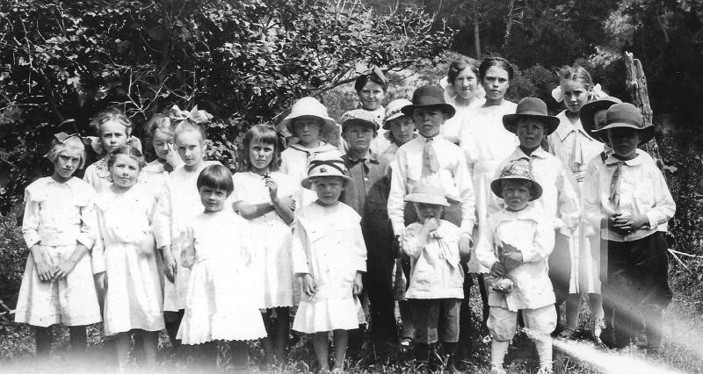
Schoolchildren at Hat Creek school, Easter, 1918. The history guide's father was the shortest young man in the front row. The tour group passed the site of the Hat Creek school, north of Lusk.

Day 2 (June 14, 2016)
Weston County Sites
The Laramie Plains Museum tours over the years have concentrated on history, but sites having interest for Wyoming citizens have been visited, too. This feature distinguishes our trips from the normal tourist excursions.
The first stop on our second day illustrates the citizen engagement portion of the tour. We visited a working correctional facility. The Wyoming Honor Conservation and Boot Camp tour began with everyone being asked to leave cell phones, jewelry, money and cameras on the bus. According to our main tour guide inside the facility, the assistant warden, "Very few tour groups EVER visit here!"
We viewed inmate housing, the education wing/library, gym/basketball court and dining hall. Our guide told us this was the "minimum security" unit for the Wyoming Department of Corrections. Inmates range in age from 18 to 72. Unlike the common misperception, it is not a "youth facility" although one unit is in place to deal with offenders between 18-25 years old. This one unit is called the "boot camp."
After lunch back at the hotel, the group went on a short tour of Newcastle. To the east of town were the remains of what had been a busy tourist attraction in the 1970s until the early 2000s. In 1966, Al Smith, a Newcastle oil driller, had leased a tract from the federal government to drill for oil. Under the lease terms, he had to show progress toward the lease or it would be cancelled. His one operating oil rig was in the field already so he decided the hand-dig an oil well on the site. At just 21 feet, he struck oil. From that discovery, he formed Accidental Oil Company. The flow was sufficient to satisfy the lease terms, but it wasn't enough to make money. Consequently, Smith turned the site into a tourist attraction. Smith died at the age of 90 in 2005. Soon, the tourist site closed, but over the years, the family has continued to produce sufficient oil to keep the federal lease. We viewed the rusting remains on the surface from the bus, disappointed that there was no one on the site to give us a tour.
During the course of our travels north from Newcastle, we passed on the highway east of the Flying V Guest Ranch, once known as the Cambria Inn or Casino. Until very recently, before it was relocated on its current route, the highway went past the elaborate entrance to the Inn. It still operates as a privately-owned bar and restaurant. The Cambria Fuel Company donated 2,280 acres of land on which the structure was built, along with an accompanying golf course. The Inn was constructed as a memorial to the miners once living in Cambria, now a ghost town, north of the site. (The townsite is inaccessible by bus). Grand opening of the new lodge included a dance on the second floor, Jan. 12, 1929, just as the mines of Cambria were closing for the final time.
We traveled to the Weston County Courthouse in downtown Newcastle. Wyoming architect Charles A. Randall designed the two-story Classical Revival building, constructed in 1910-11. The ornate structure (with Beaux Arts details) includes a memorial on the front lawn to native son Keith Thomson, former U. S. Representative. Thomson, then Senator-elect, died suddenly Dec. 9, 1960, just weeks after his election. He was just 41.

We visited the Weston County Library, next door to the courthouse. Librarian Brenda Mahoney-Ayres showed us the circulation desk, the same one used in the earlier library building constructed partially through a $12,500 Carnegie Library grant in 1911. The original library opened to patrons on Aug. 10, 1912.
Newcastle's downtown still features numerous historic structures, but several others have been destroyed by fire over the years. Mary, one of our group, was born and reared in Newcastle. Her family owned and operated a historic drugstore that stood on Main Street for more than 80 years until the building and three adjacent historic structures were destroyed by fire on Dec. 18, 1998. Debbie and Paula were educated in Newcastle. All three provided the group with anecdotes about downtown buildings such as the historic theatre and the now-abandoned school building. We learned rattlesnakes commonly are spotted around Newcastle. (The local newspaper reported that ten family pets had been bitten by rattlesnakes so far this summer in the area).
In the afternoon, after lunch at the hotel, we visited the Anna Miller Museum. Weston County was the first in the state to authorize a tax levy to support a museum district. The museum is housed in what had been the National Guard armory and cavalry barn, built by the State of Wyoming in 1917. The museum contains artifacts describing the history of the county, including items from the historic Kahlil Farrar Co. store and the Cambria Mining Company. Next door to the museum is a caboose that once ran on the Chicago, Burlington and Quincy line that passed through Newcastle. In an adjacent building is a linotype machine, the typesetting apparatus once used by the Newcastle Newsletter Journal weekly newspaper. The building also houses a safe that was guaranteed to be the most difficult to "crack" in the industry. Across the street are three buildings: a homesteaders' cabin, a historic schoolhouse, and a building from the Jenney Stockade. All three were moved to their current locations in the past 30 years. The stockade was constructed in ten days in 1875 as a supply depot for all military camps in the vicinity of the Black Hills. The buildings were best known as a stage stop on the Cheyenne and Black Hills stageline. The stages began night runs between Hat Creek stage station and Jenney Stockade station on April 10, 1877. The stockade station was a breakfast and supper stop for stage passengers. Even though it is ineligible for National Register nomination because of its move from its original location, it is the oldest structure in Weston County.
The group enjoyed a "home-cooked" lasagna dinner at Donna's Main Street Diner. Donna, the owner and chief cook, made the entire diner available to our party. Along with the lasagna, the cobblers were a hit as well. In the evening, the group convened in a meeting room at the hotel to hear Dr. Charles Reher, professor at the University of Wyoming, present on archaeological sites in eastern Wyoming, ranging from Pine Bluffs to Spanish Diggings and the Vore Buffalo Jump site where the group was to visit the following morning.

(Go to the next link to view the second part of the trip).

