June 20, 2012
2012 Wyoming on-the-road tour
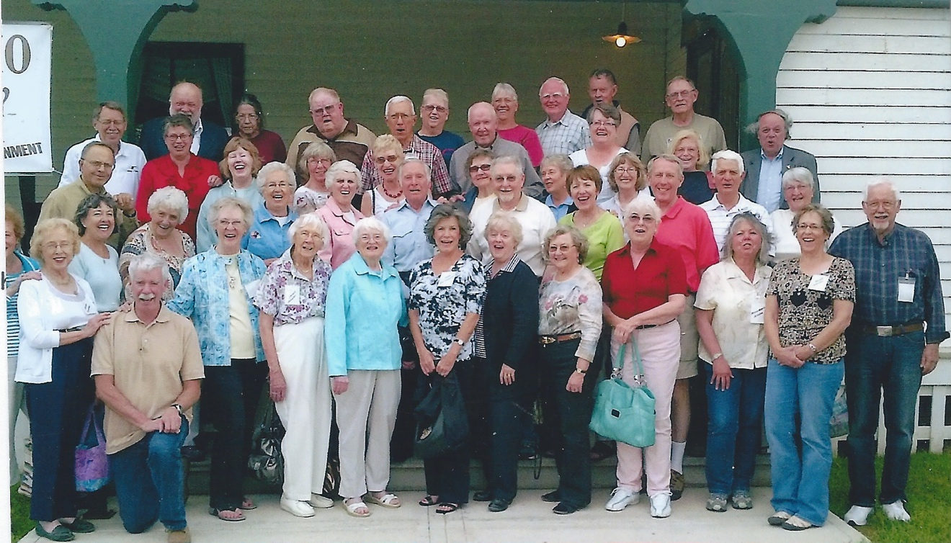
The 2012 edition of the "History of Wyoming on-the-road tour" was sponsored by the Laramie Plains Museum and the accommodations/meals/special events were organized by Barbara Barnes who did a superb job. More than 40 participants took the bus trip from Laramie to Evanston, north to Jackson, through Yellowstone to Cody, Powell, Worland, Sheridan, Casper and back to Laramie. As on past trips, I served as the history tour guide.
The group toured historic Fort Bridger, the railroad roundhouse complex in Evanston, Aviat Aircraft's factory in Afton (builders of high-performance aerobatic airplanes, pictured below), the Buffalo Bill Historical Center in Cody, the new Heart Mountain Interpretive Center, the new Washakie Museum and Cultural Center in Worland, the Medicine Lodge State Archaeological Site (photo below), King Ropes and the Sheridan Inn in Sheridan.
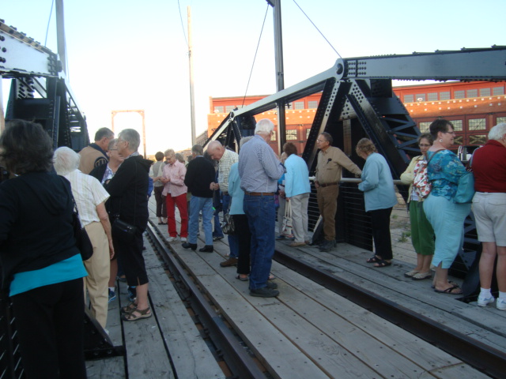
Along with visiting historic sites, the group heard special speakers including Frank Prevedel in Rock Springs, talking about Superior and his new book on the historic coal-mining town east of Rock Springs. Jim Davis spoke on the restoration of the Evanston Roundhouse and provided a tour of the still-evolving center being developed on the site. In Worland, Dr. George Frison addressed the group about the Colby site and his extensive study of mammoth kill sites.
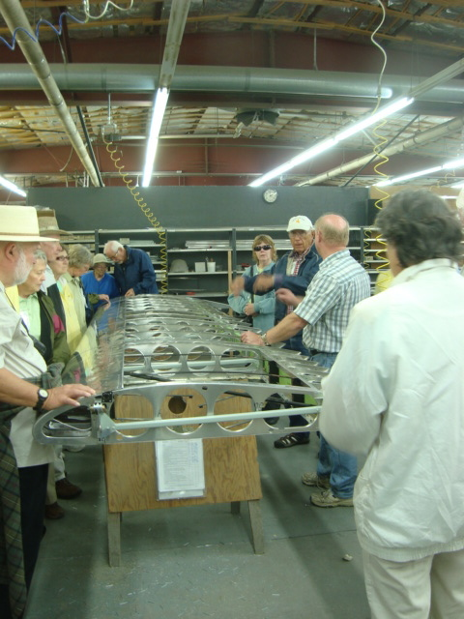
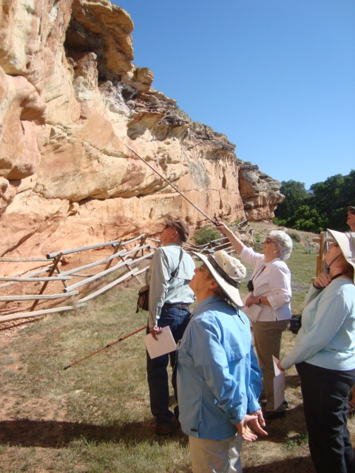
At the Medicine Lodge site, Margaret and Tom Harless pointed out many significant petroglyphs and talked about the meaning of the site. Wayne Baumann portrayed Buffalo Bill at the Sheridan Inn and answered questions about the old scout's life. Various trip participants talked about areas where they had specific knowledge
__________________________________________________________________________________________
January 10, 2014
Plans Announced for 2014 Wyoming on-the-road tour
The 2014 History of Wyoming "on-the-road" tour features visits to numerous historic sites and points of interest in central Wyoming. Centered in Casper, the day-trips will go in all four directions from there, including stops at Independence Rock, Fort Fetterman, Kaycee and Hole-in-the-Wall country, and the Trails Center and Fort Caspar in Casper. For more information, contact Mary Mountain at the Laramie Plains Museum, Laramie.
___________________________________________________________
Wyoming History Tour, 2014
The 2014 tour for the Laramie Plains Museum "History of Wyoming on-the-road" tour began June 9, 2014, and ended June 14, 2014. This section provides day-by-day commentary of places the 42 people on the tour visited and a few photographs from some of the sites. The next tour was in early June 2016. Contact the Laramie Plains Museum for more information about further tours.
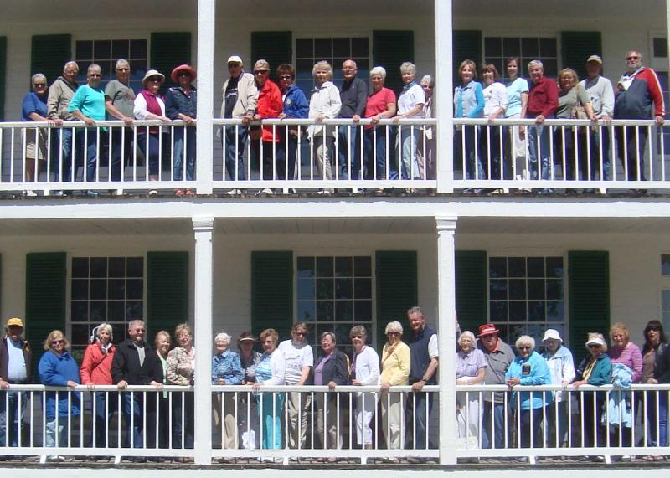
Trip participants posing on the porches of Old Bedlam, Fort Laramie National Historic Site, on the final day of the tour. Photo by Keith Smeules.
﻿
Below is a photograph of what Old Bedlam looked like in 1935, just prior to the State of Wyoming obtaining the site for restoration. The site became a national property, administered by the National Park Service, in the late 1930s.﻿﻿
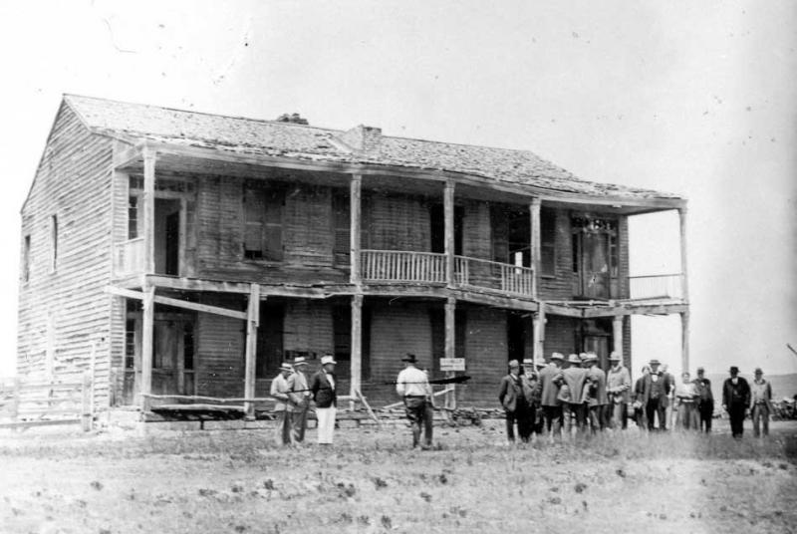

DAY 1: Laramie-Rawlins-Independence Rock-Casper
Rain fell on the Laramie Plains the night before departure and the prairies west of Laramie were green and lakes filled with water. It was easy to see why Charles Jordan on his train trip west in 1923 might have been inspired to create his famous advertisement for his Jordan touring car—“Somewhere West of Laramie” While no young woman on a horse raced the bus like the rider who raced Jordan's train, the countryside inspired a sense of why we love living in the Wyoming high country.
After brief mention of "Avocado Hill," the guide spoke of the Overland Stageline stations built along the general route in 1863. The trail segment from Fort Collins to Fort Halleck﻿ was guarded by soldiers, including "galvanized Yankees," commanded by Col. William O. Collins for whom Fort Collins was named. His young son, 20-year-old Lt. Caspar Collins, was killed by Indians at Platte Bridge Station in July 1865 and the army post there was renamed in his honor--Fort Caspar, given that "Collins" already had been used to name a fort in the area. Meanwhile, army consolidation of troops caused Fort Halleck to close and much of the equipment and troops were sent to build Fort John Buford (later Fort Sanders), south of present-day Laramie.
Even though the Overland stageline no longer operated after construction of the transcontinental railroad, Fort Sanders was in place to house troops to guard railroad workers on the Laramie Plains segment, once tracks had passed over the summit and the highest railroad bridge in the world at the time--the Dale Creek trestle--was completed in the spring of 1868.
Farther west, the army built Fort Fred Steele at the point where the tracks crossed the North Platte River. Just beyond that point, a town unauthorized by the Union Pacific Railroad, known as Benton, popped up as a "hell-on-wheels" end of tracks town. The place, where one often had to walk in alkali dust more than a foot deep, became notorious for having the highest homicide rate of any place on earth in its barely three months of existence.
WYOMING FRONTIER PRISON
The tour stopped at the Wyoming Frontier Prison where veteran site director Tina Hill gave a tour of the site that served as Wyoming's only prison from 1903-1982. Highlights included Cellblock A, and the death house where Wyoming's gas chamber operated from the middle 1930s until 1965.
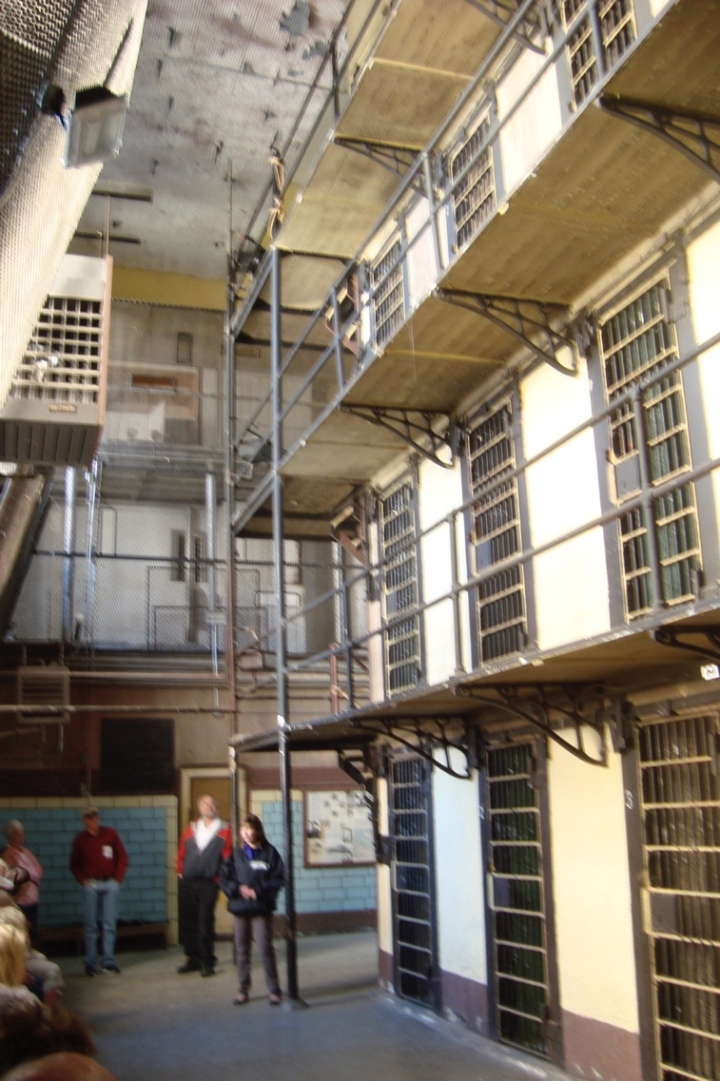
Site director Tina Hill tells of hanging of Frank Wigfall inside the prison cell block.
Travelers walked through the dining hall (below) with unique paintings "keeping an eye
on you" regardless of where you are in the room.
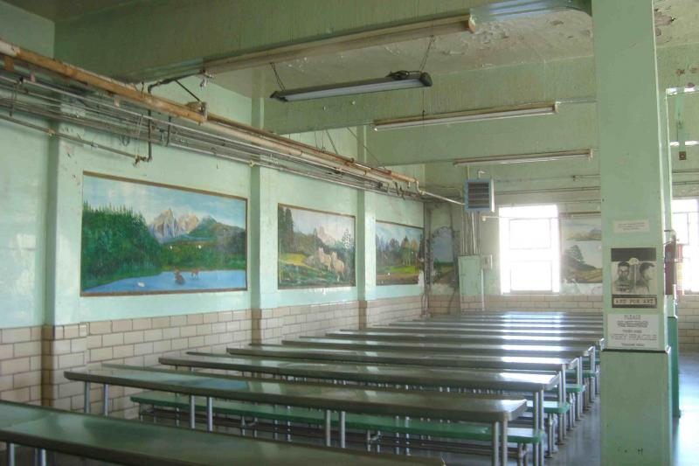

After a fried chicken lunch at Cappy's, it was off to Independence Rock. Numerous wind farms now appear around Rawlins and, soon, one of the largest wind farms in the U.S. will be constructed on Anschutz property south of town. The story of Big Nose George and Dutch Charley made for rather tasteless after-lunch comments from the history guide.
The bus followed the highway north of Rawlins. To the west was Green Mountain, where uranium was mined in the 1950s and the boomtown of Jeffrey City to the east, Whiskey Gap and the Freezeout Mountains.
INDEPENDENCE ROCK
As the bus came to the Carbon-Natrona county line, the history guide told the story of the lynchings of Ella Watson and James Averell. Both were small rancher/homesteaders who took out 160-acre homesteads on the open range that big area ranchers thought they were entitled to. The ranchers wouldn't purchase the land when the federal government offered it, preferring to use the grass and water for free, without having to pay the federal government for it or pay any taxes on the land. Yet, they believed they ought to be given exclusive rights to use the land in a common example of "entitlement," still universally believed by those who decry federal regulations and assistance to less the fortunate, but who are never shy about taking whatever they can from federal lands. Cheyenne newspapers, in sympathy with the big ranchers who lynched Watson and Averall from a scrub pine along the riverbank of the Sweetwater River, dubbed Watson "Cattle Kate." They ascribed all sorts of nefarious activities to the young Kansas woman who was not guilty of any of the assumed offenses--except for having the audacity to homestead in the middle of the public domain that big ranchers believed belonged to them. None of the lynchers ever stood trial for the crimes.
Independence Rock, called "the register of the desert" by Father DeSmet, has on it thousands of carved signatures of Oregon-California trail travelers. The name likely dates to the early fur trade era and might refer to the rock's "independent" location away from other landmarks or because early trappers celebrated the 4th of July next to the rock. Now a state historic site, Independence Rock once served as the point where trail travelers believed they'd have to pass by July 4 if they were to beat the snows over the Sierras or the Blue Mountains toward the end of their journeys. While existing signatures are carved into the rock, in trail days, names were often written on the rock with paint or grease or oil. Purpose was to inform friends arriving later that the signers were up ahead and had made it to that point on the trail.
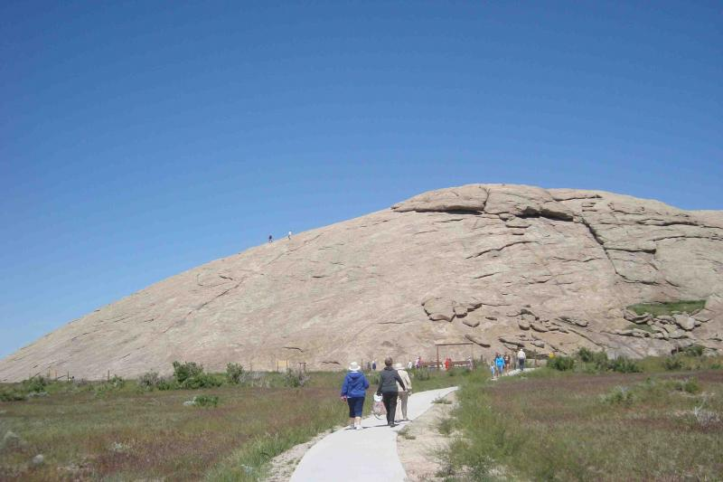
Tour participants enjoyed a breezy walk to the Rock.
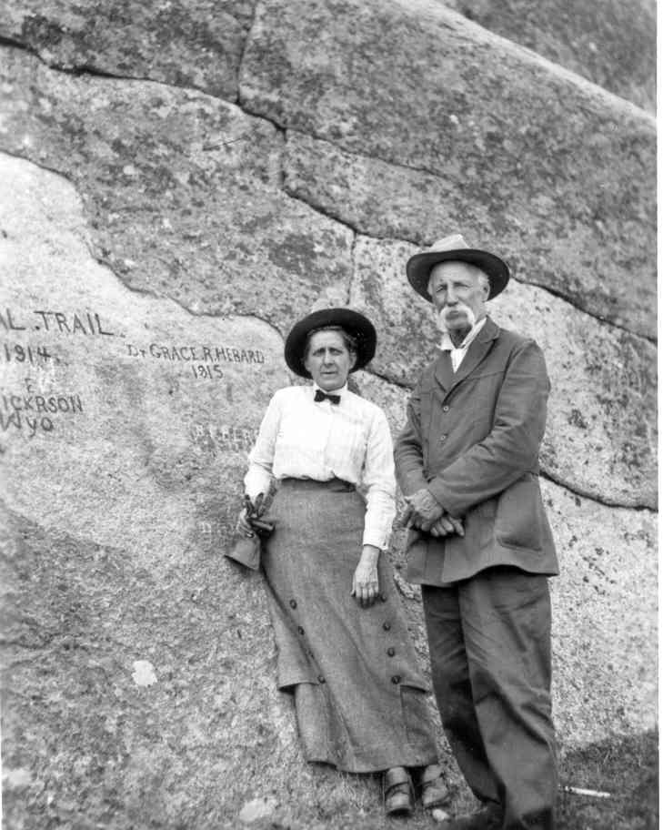
Historic photo of Dr. Grace Raymond Hebard and Capt. H. N. Nickerson
at plaque dedications at Independence Rock about 1930.

The tour continued with Pathfinder and Alcova reservoirs along the North Platte River to the right of the bus. The U. S. Bureau of Reclamation dams contributed flood control, irrigation and power generation to central Wyoming.
DINNER AT THE NIC
The Monday night dinner in the main lobby of Casper's Nicolaysen Art Museum featured prime rib or chicken, salad, potatoes, wine, and delicious cake for dessert. Nic director Brooks Joyner welcomed us to the museum and we viewed the exhibits, including assorted works by the late Cody-based sculptor/artist Harry Jackson. The studio exhibit of Laramie-born artist Conrad Schweiring contained portraits and other paintings not normally associated with the artist, known for his landscapes of the Tetons. An interesting special exhibit of Brazilian folk art also was on display in the galleries.
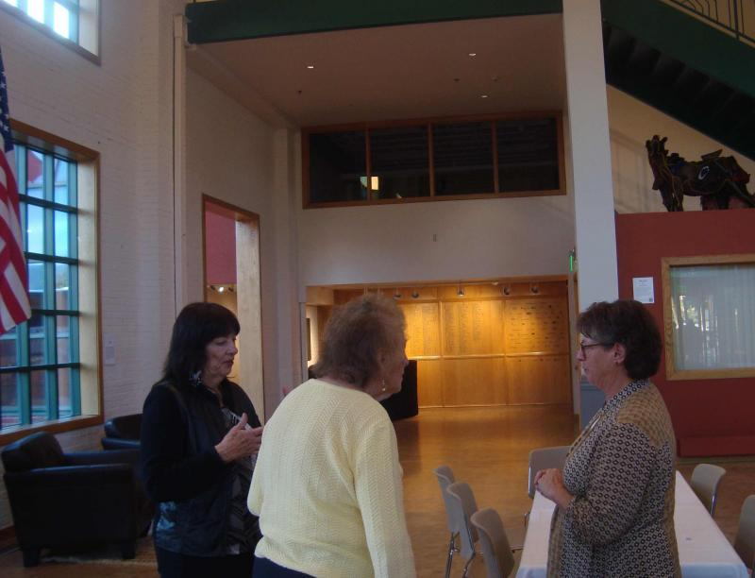
DAY 2: Casper-Lander
The trip from Casper to Lander involved passing through a half dozen US Highway 20 places and along what once had been two parallel competing railroad lines.
The first small community on the route, Natrona, is also the name of the county. Both derive their names from trona, the Na indicating that it contains sodium. Huge piles of trona once stood along the highway as the substance, sometimes referred to as "saleratus" by Oregon Trail travelers who used it to bake biscuits, was prepared for rail shipment. With huge trona deposits being mined in the Green River Basin, west of present-day Green River, surface scraping of trona is no longer profitable.
Powder River is a village named for the river, barely noticeable at this point close to its origin. Here, the story was told of Missouri Bill Schultz, a cowboy who volunteered for a cattle drive from Lander to Casper in the late 1880s. He was told he'd have to ford the cattle over Powder River and he assured his new bosses that he was accustomed to fording them over the Missouri River so he ought to be able to handle them over Powder River. For weeks as the trail drive moved east, other cowboys kept warning Missouri Bill that he'd better be ready because, soon, they'd have to ford Powder River. When they came to the spot where the "river" was barely a foot wide, Bill recognized he'd been the victim of a joke. Nonetheless, when the drovers got to Casper, Bill went into a Casper bar and yelled that he'd made it across Powder River! "Powder River, Let 'er Buck!" he shouted. Soon, the saying was adopted by other cowboys and, later, by Wyoming soldiers in World War I. The saying meant that oftentimes, the unknown challenges lying ahead turn out not to be so insurmountable. Thus, "Powder River, Let 'er Buck"--it might look tough from here, but we can overcome whatever comes our way.
Beyond Natrona is Hell's Half Acre, once named "Devil's Kitchen" by old-time cowboys. The site, once a popular, highly-advertised tourist stop on US 20, actually consists of 320 acres of multi-colored canyons, cliffs and rock formations. Now a county park, the site was used for filming scenes in the1996 sci-fi film, Starship Troopers (as the giant bug-controlled planet of Klendatha). Many area residents had bit parts in the movie.
Down the road, before reaching Waltman, the road passed over the Bridger Trail. Jim Bridger pioneered the little-used route for miners to travel to the Montana gold fields, passing on the west side of the Big Horn Mountains. It was designed to be a safer alternative to the Bozeman Trail along the east side of the mountains and through Indian hunting lands.
North of the present highway route is the town of Arminto, named for Manuel Armenta, a sheep rancher and owner of the Jack Pot ranch. Once a thriving railroad stop, the post office there closed in 1964.
Across this 100-mile stretch, two railroad lines ran parallel to each other. The Chicago and Northwestern tracks eventually turned southwest toward Lander, with the company's original intent to build all the way to the Pacific unrealized. The Chicago, Burlington and Quincy eventually built through Wind River Canyon and on through the Big Horn Basin to Laurel, Montana. During World War II, the Burlington and Northwestern consolidated 87 miles of their tracks in order that the duplicate rails could be pulled up and salvaged for the war effort.
We passed by the Hiland store in the small village of Hiland, Wyoming. There, author Betty Everson sold store goods to travelers and area ranchers and, in the quiet moments, wrote romantic novels.
Beyond Hiland, antelope roam on the empty plains. Near here is the geographic center of Wyoming. The spot figured into the capital location election of 1904. During the heated contest between Cheyenne, Lander and Casper to gain the permanent location of the state capital, WIllis Emerson proposed a novel solution. "Why not locate the capitol building in the exact center of Wyoming--near the banks of Muskrat Creek?" he asked. His suggestion was not followed and Cheyenne retained the temporary capital. Had his plan succeeded, Wyoming would have been the only state with a capital named for a rodent!
Moneta, the next village along the highway, once had numerous sheep-shearing pens. Throughout this area, sheep ranches dominated the local economies in the territorial period. Among the important sheepmen in the area was J. B. Okie who built a mansion at Lost Cabin that he named the "Big Teepee."
North of the highway, on Aug. 13, 1998, the Cave Gulch oil field experienced a massive explosion and fire. It burned throughout the fall and winter before being extinguished by professional oil firefighters, not unlike those portrayed in Hellfighters (1968), a movie made near Casper starring John Wayne and Vera Miles.
Farther north of the highway is the site of the Bates Battle (July 4, 1874) in which army troops and Shoshone allies battled Northern Arapaho. Three years later, the federal government forced the Shoshones to host the Northern Arapaho as temporary guests on the Shoshone reservation while the government prepared a reservation for them in northeastern Colorado. As years went by, the government could not get lands for the Arapaho and, consequently, in the 1920s, the Shoshonis were forced to accept the Arapahoes as joint tenants on the newly-renamed Wind River reservation.
To the right of the highway and north is the railroad stop of Bonneville. There, trucks loaded with trona from the Green River Basin off-load their shipments onto Burlington Northern railcars. High in the Owl Creek mountains farther north is the site of Quien Sabe ranch where Butch Cassidy and his gang stayed while evading officers after their numerous robberies. "Who knows?" why the ranch was given the Spanish name.
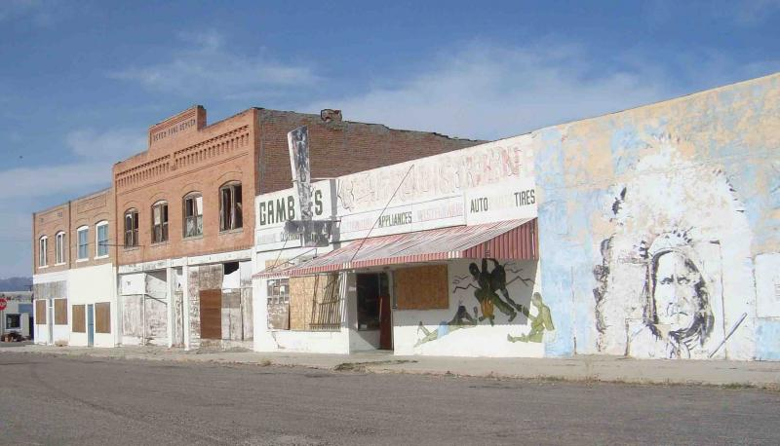
Shoshoni, once a thriving irrigation agriculture center and transportation hub for mineral development, now seems largely abandoned. The Yellowstone Drugstore once occupied a downtown corner where it sold thousands of malts each summer. (The store closed about 2005). C. H. King was one early entrepreneur in Shoshoni, operating a Casper-Lander transportation company and lumber yard. (He is now remembered mostly as the grandfather of President Gerald R. Ford--the father of Ford's estranged natural father, Leslie King).
Boysen Reservoir seemed more full than in past years. The coal-mining town of Hudson featured two long-time rival restaurants, the El Toro on the west side of main street and Svilar's on the east side.
At Riverton, the issue of Indian sovereignty was discussed. Just beyond town were two Indian casinos, both opened in the 2000s.
The first scheduled visit was to Eagle Bronze, a foundry for sculpture works, south of Lander. There, we viewed monumental sculpture works in various stages of casting, including two gigantic horses bound eventually to Dubai or Abu Dhabi (below).
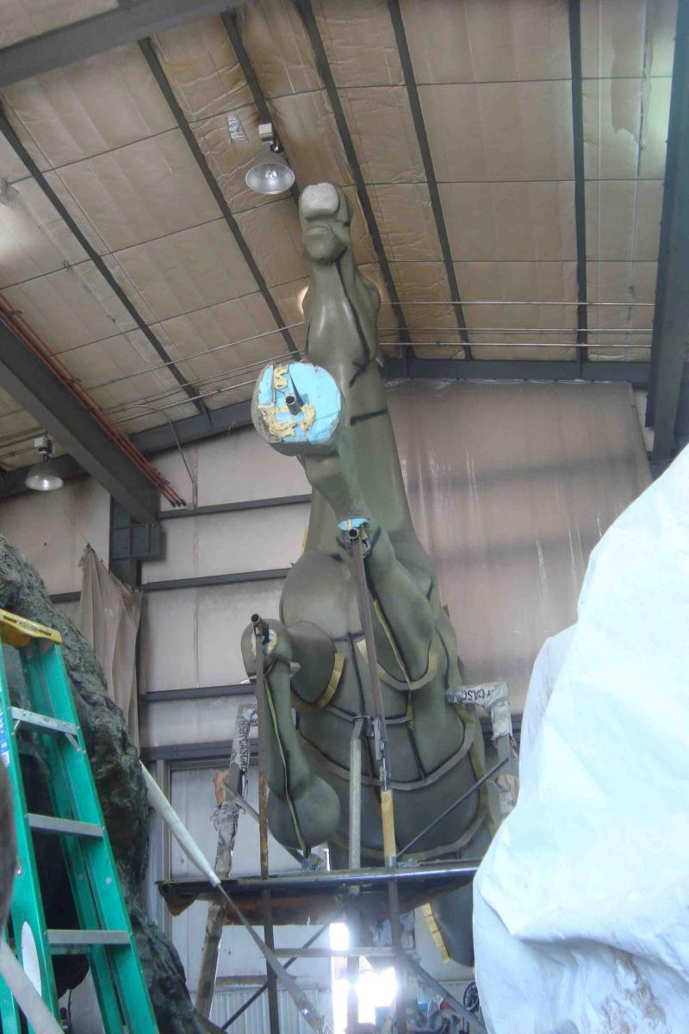
One pair of bronzes, an Indian warrior and a buffalo, were seen again later when they were placed in front of Fort Caspar. Travelers looked at various other bronze pieces cast by the firm, including longhorn steers originally cast for the civic center in Dallas,Texas (below).
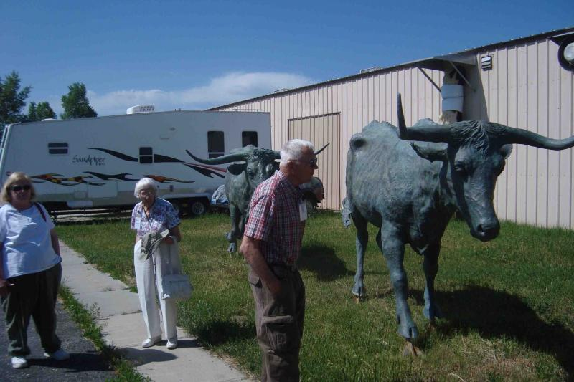
Later, after lunch at Gannett Grill in downtown Lander (on picnic tables outside in the pleasant mid-day air), the group went to the National Outdoor Leadership School (NOLS) to hear a talk about the world-renowned wilderness school.

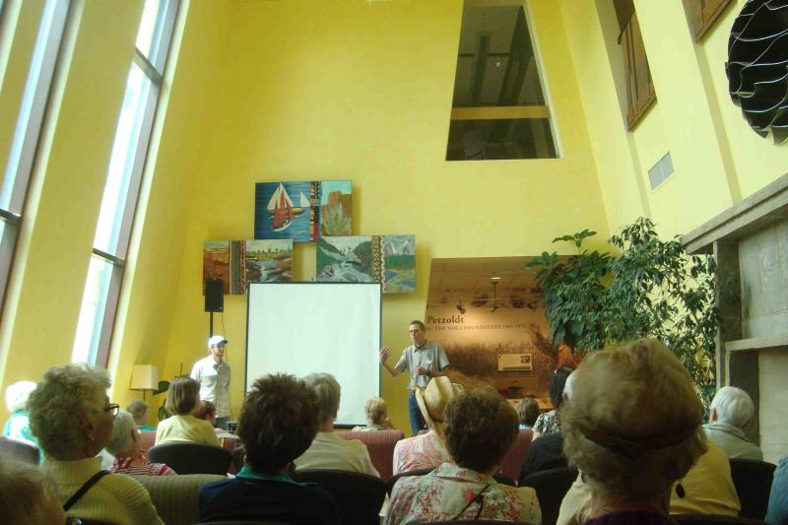
Back later at the hotel and a catered dinner of lasagna, the group enjoyed bingo, utilizing 1950s vintage bingo equipment from the IOOF lodge.

